Problem 7:

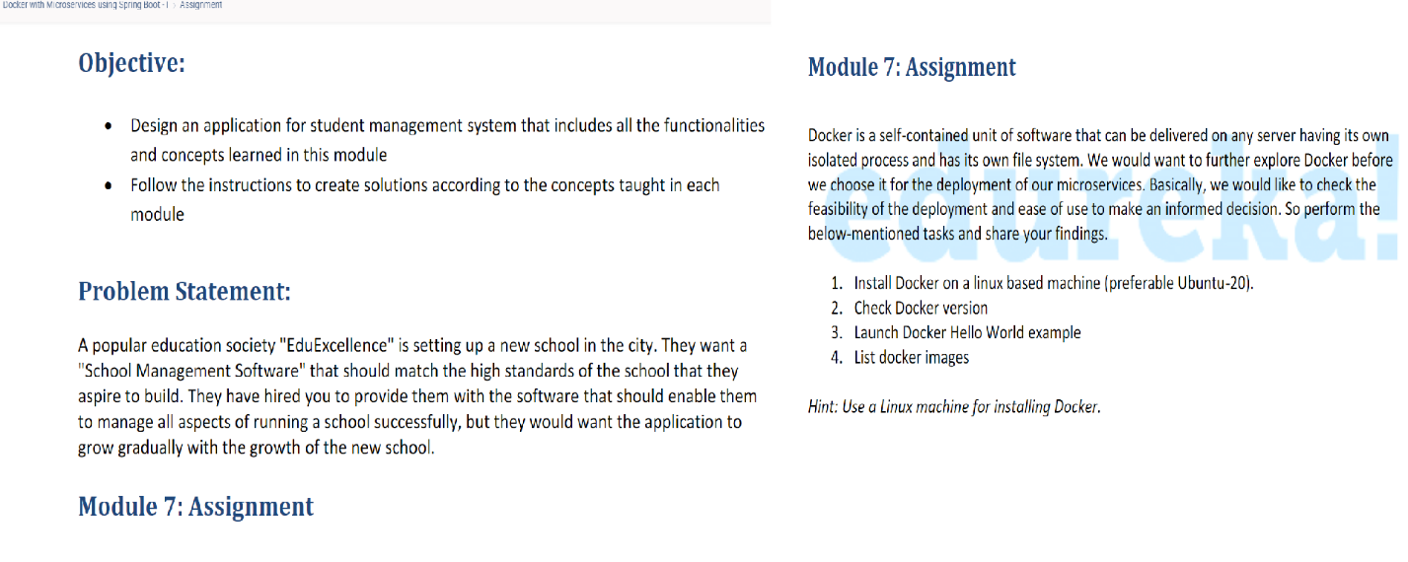

1.Created EC2 instance and connected to it

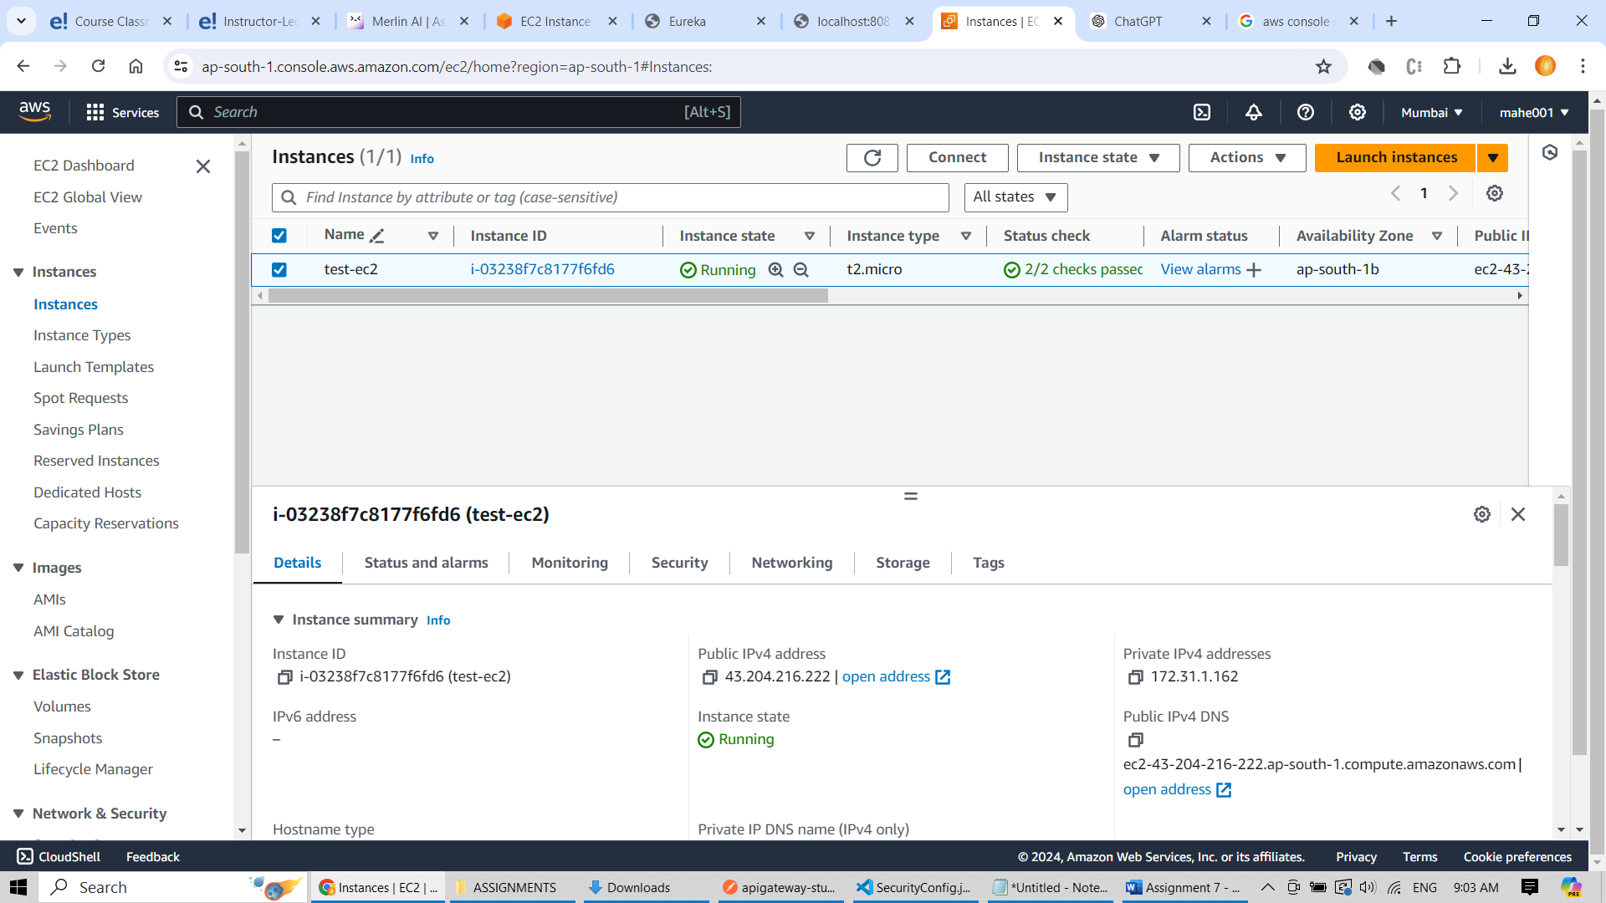

2.Run following commands in order

* Sudo su – login as a super user
* ”apt update” - to update the os
* “apt install docker.io” – to install the docker

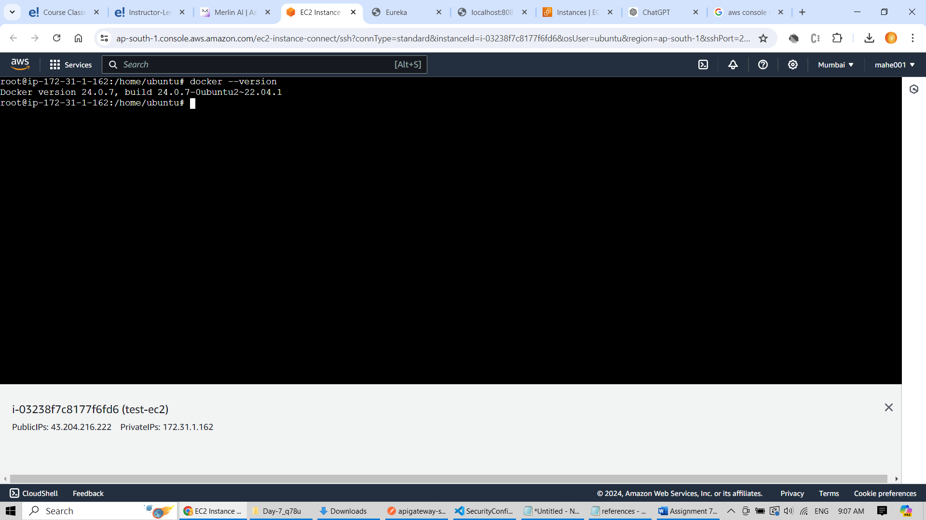

3.Run hello-world image

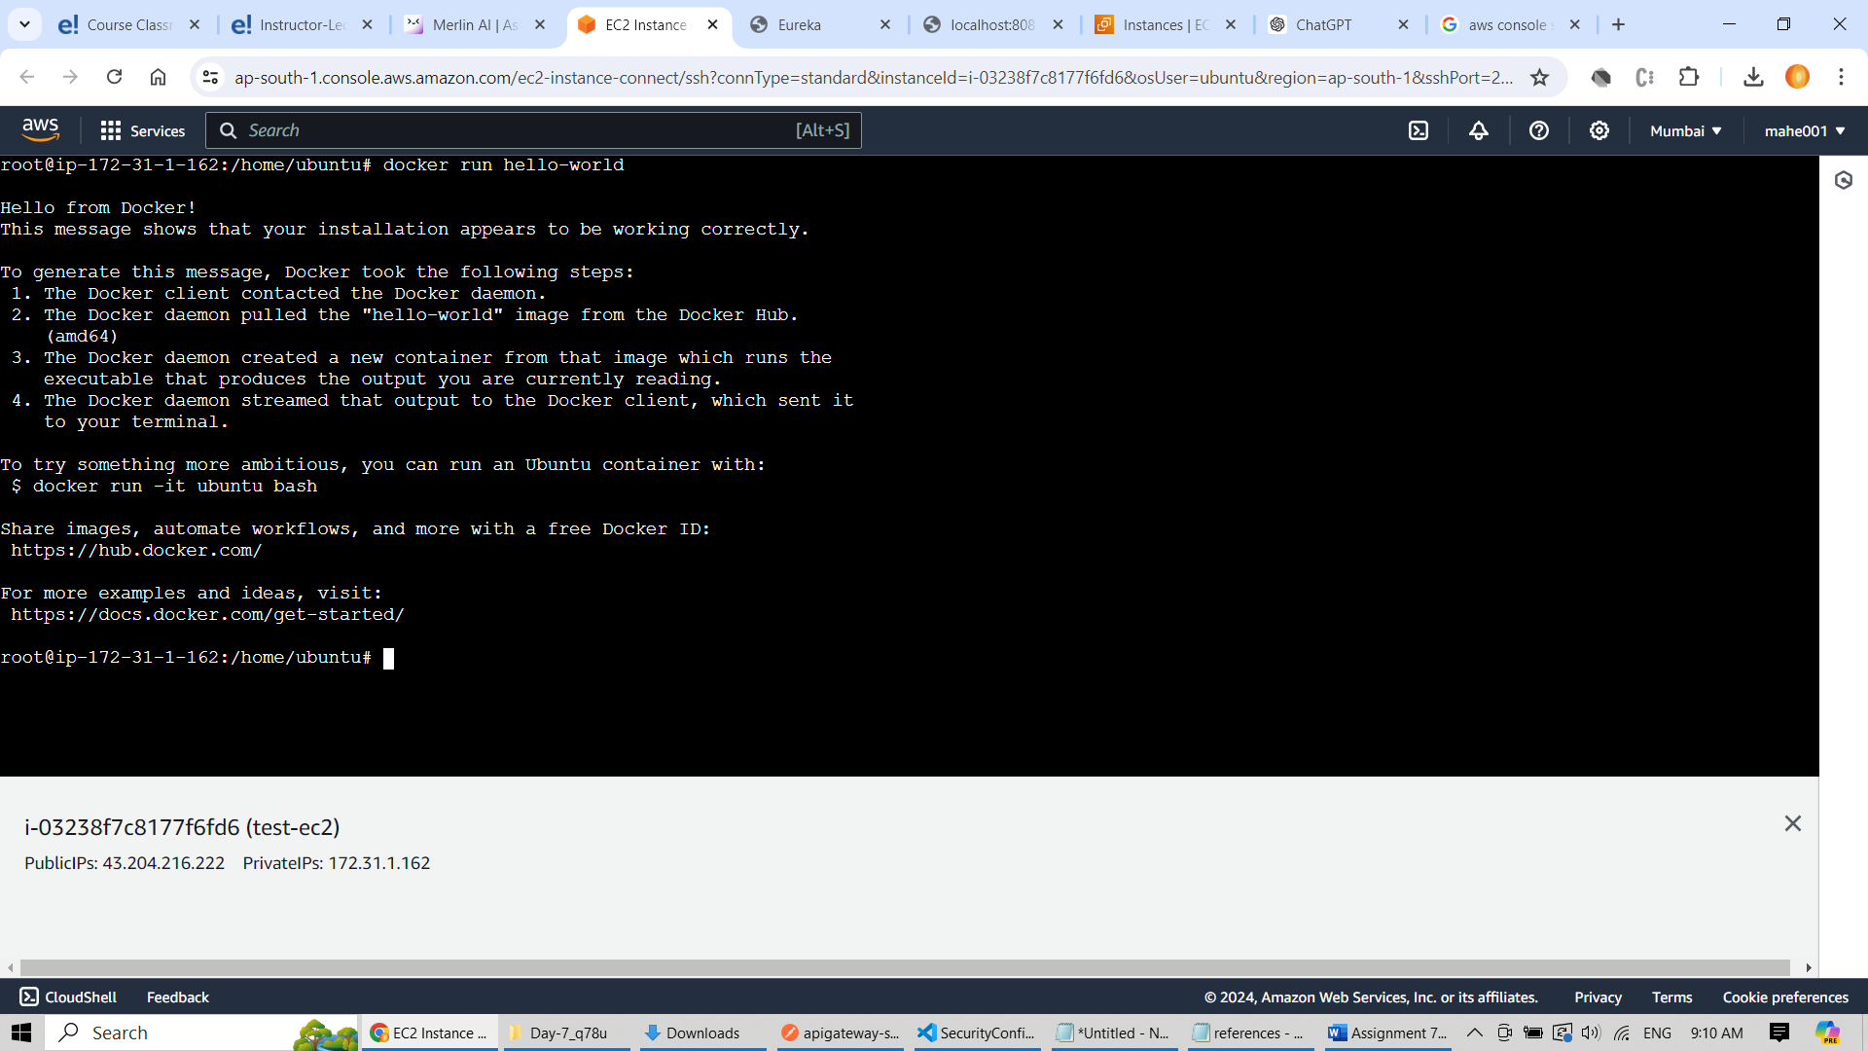

4. List docker images

